*TensorFlow Model Training Data:*

Contents

Training Models: 2

Completed Models Training: 7

Faster_rcnn_final: 7

SSD_ResNet50_Final: 8

SSD_resnet152_final 9

Faster RCNN Resnet152: 10

Confusion Matrices: 11

Faster RCNN Resnet 50: 11

Faster RCNN Resnet 152: 12

SSD Resnet 50: 13

SSD Resnet 152: 14

# Training Models:

1. faster_rcnn_resnet50_v1_800x1333_coco17_gpu-8

Total Loss when training ended: ~0.2

Time training elapsed: 11 hour 44 minutes

mAP score: 0.5689

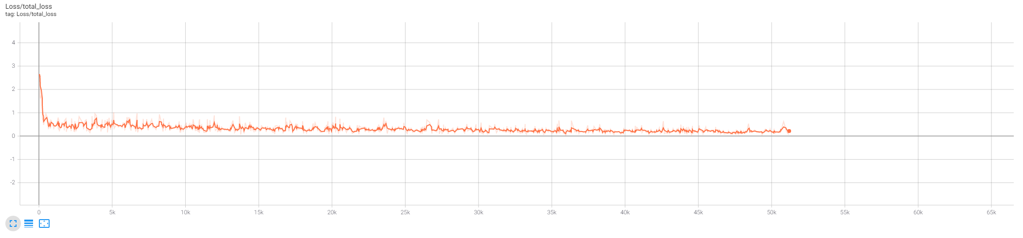

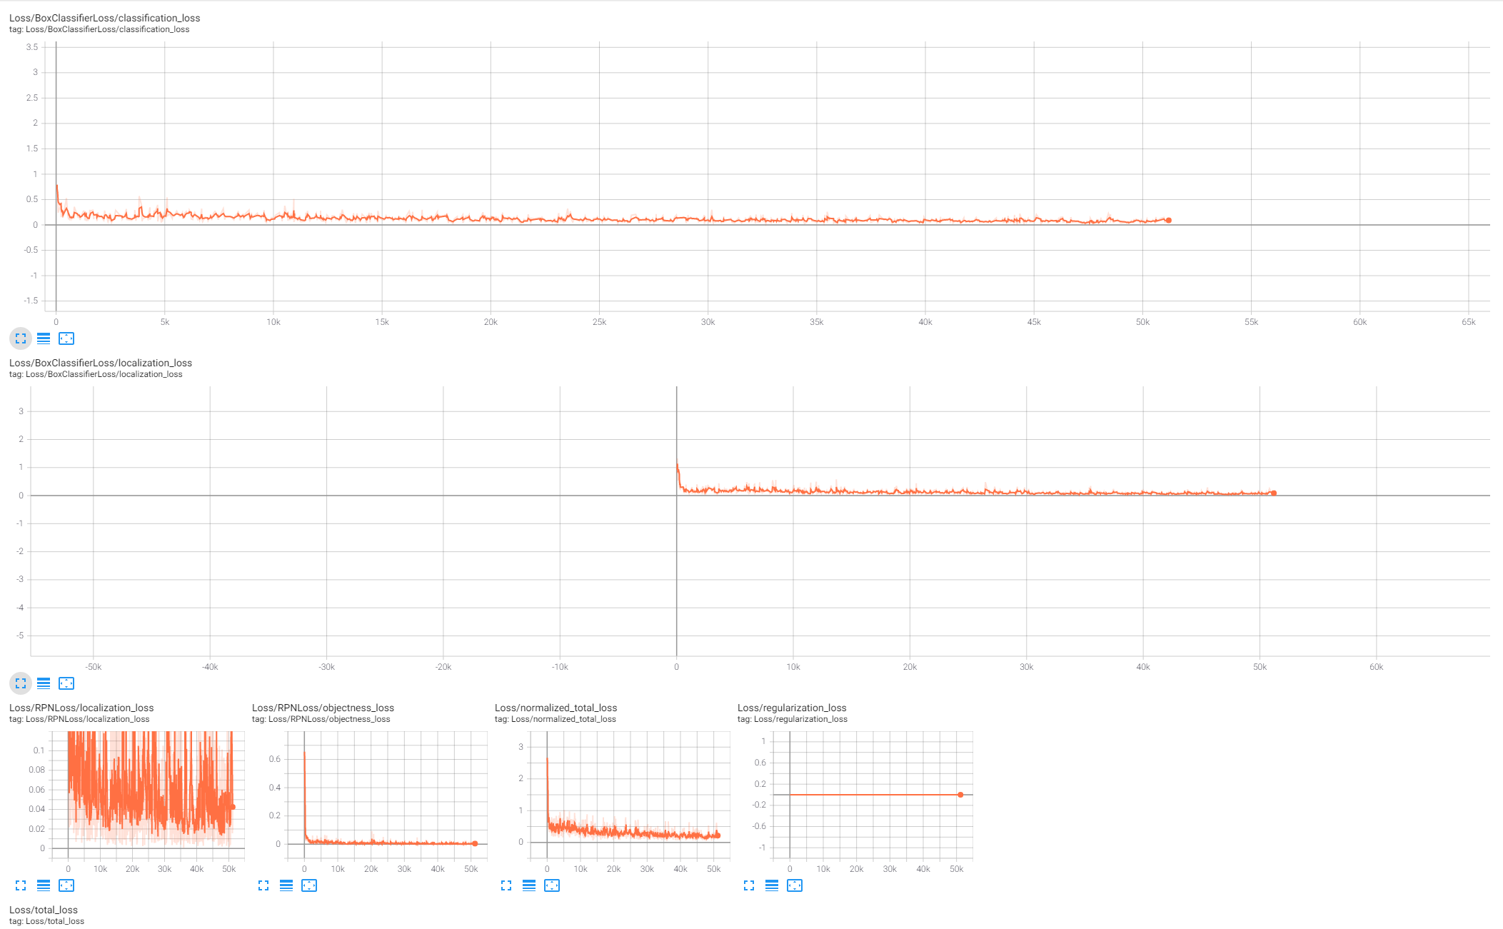

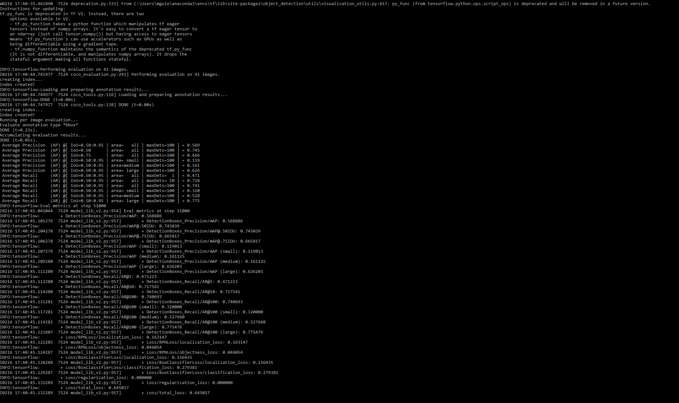

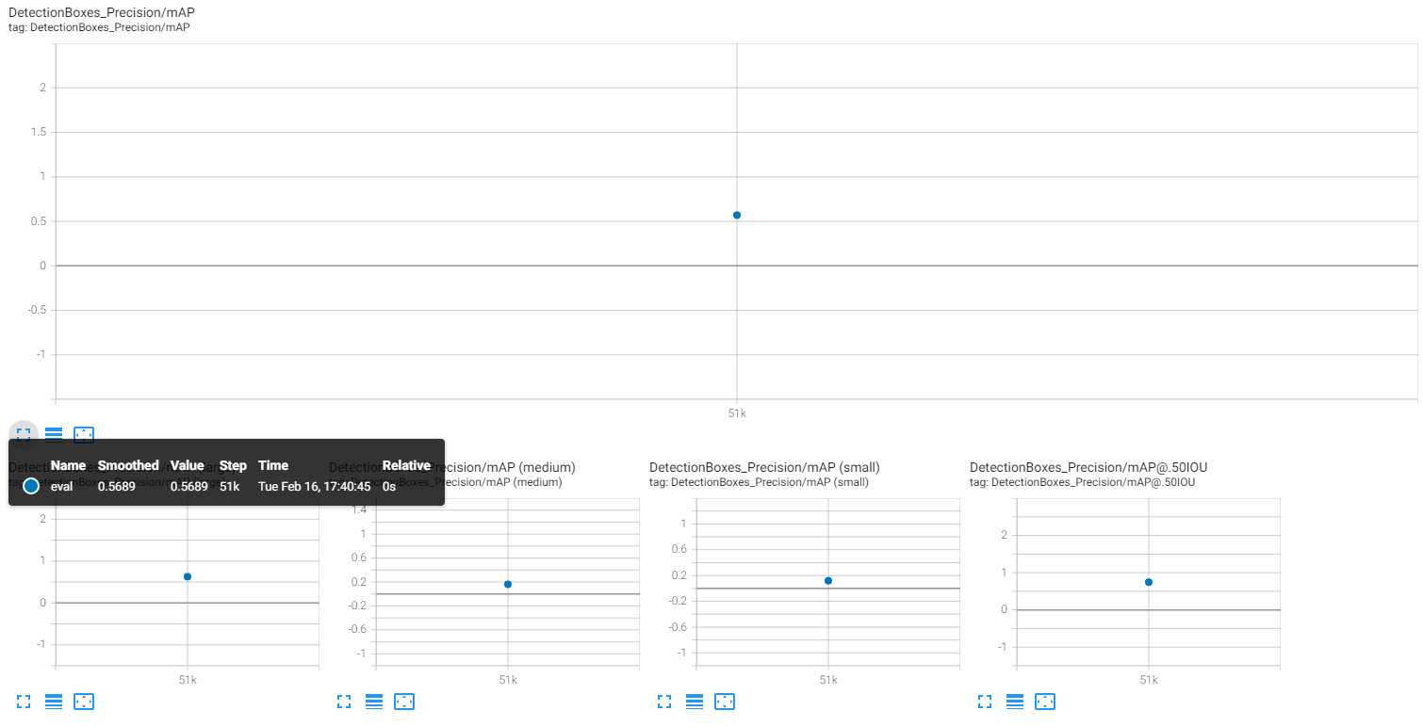

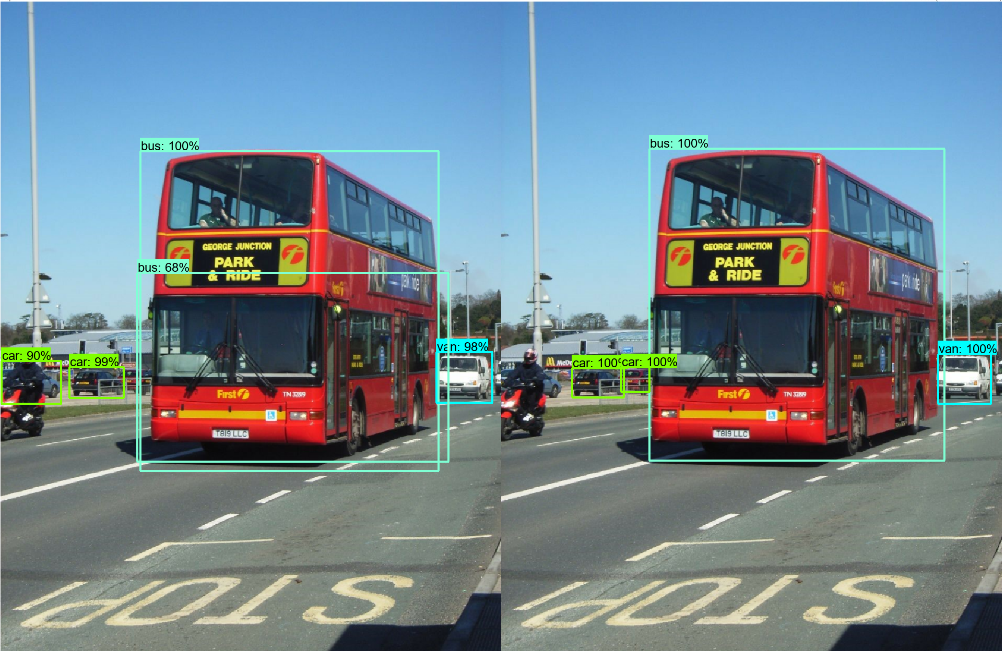

1. Faster R-CNN Resnet50 (Trained on Google Colab TESLA T4 (16GB VRAM)

Total Loss when training ended: ~0.57

Steps: 24000

Time training elapsed: ~ 12 Hours

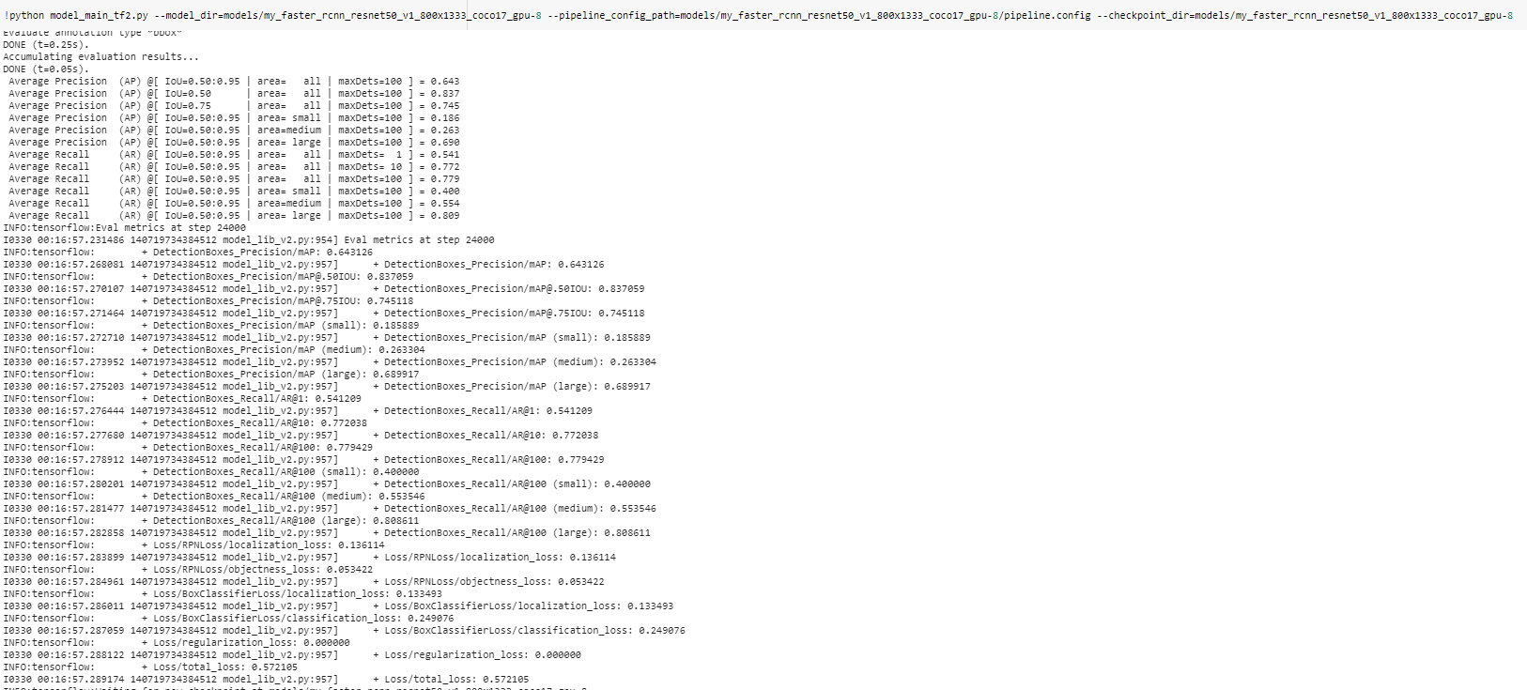mAP score: 0.643

* Had a batch size of 4 instead of 2 when run on my pc.
* Converged much quicker on Colab GPU but randomly ended.
* Still gave higher accuracy.

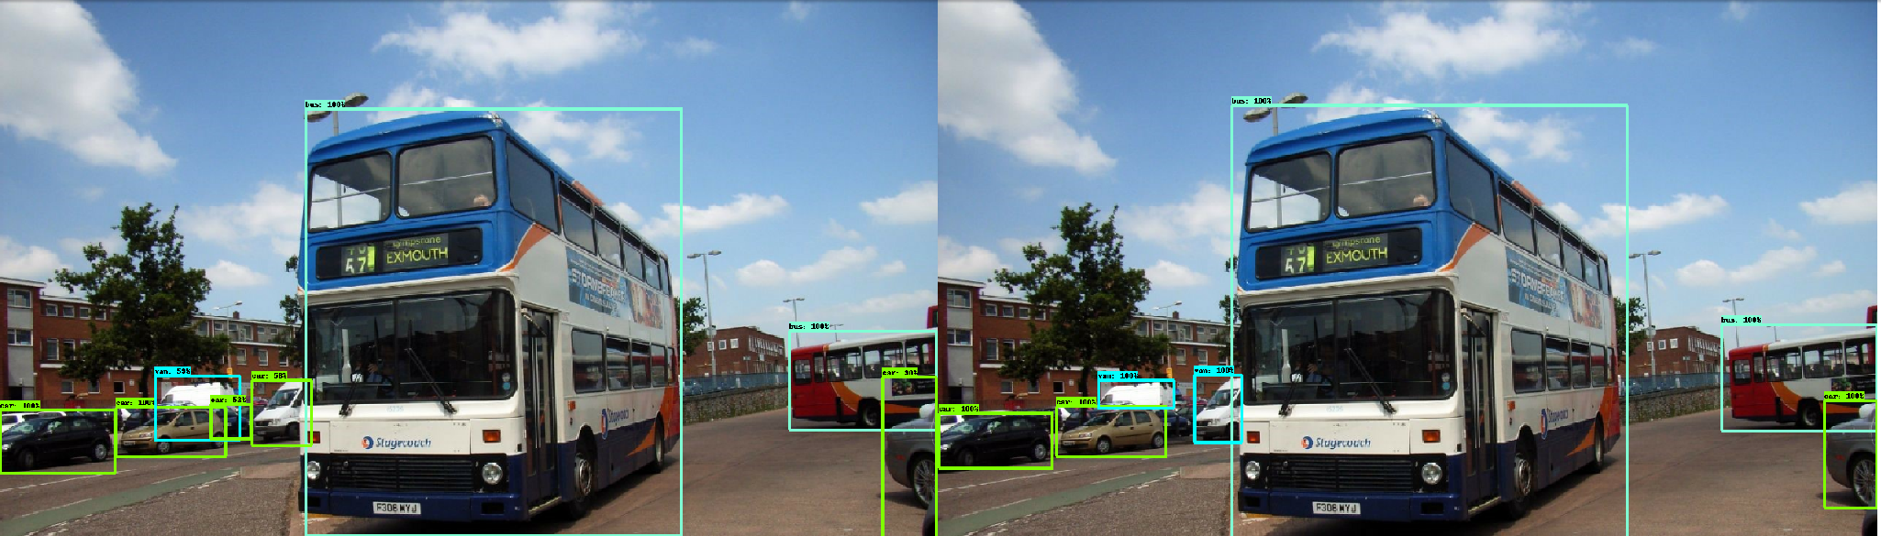

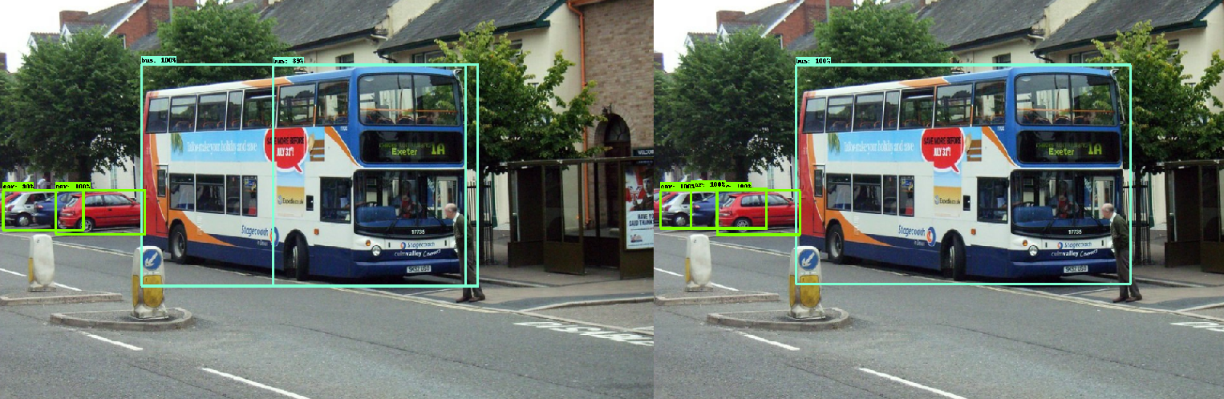

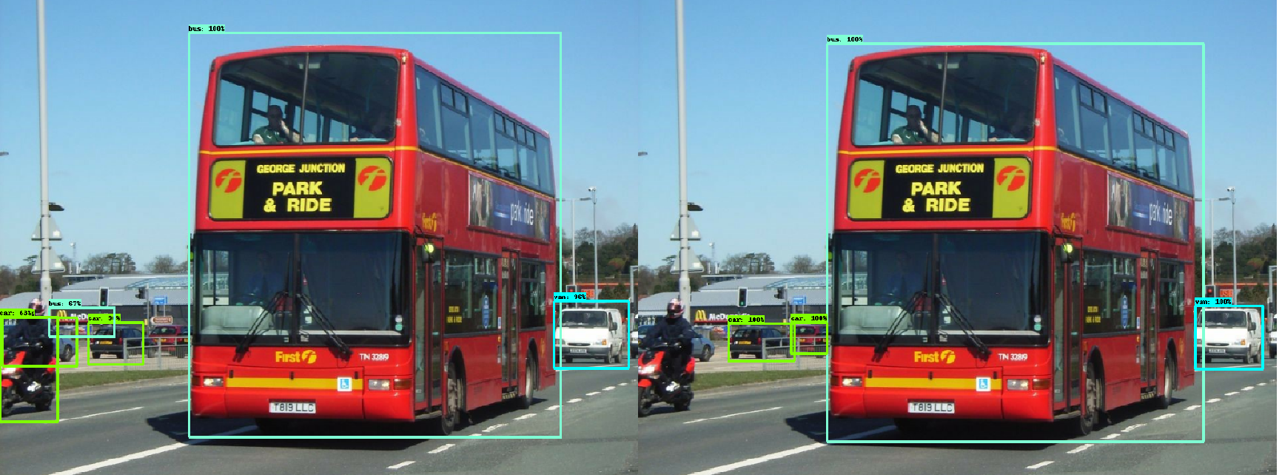

1. SSD RESNET 50:

TRAINED ON GOOGLE COLAB GPU: TESLA T4 (16GB VRAM)

STEPS: 20000

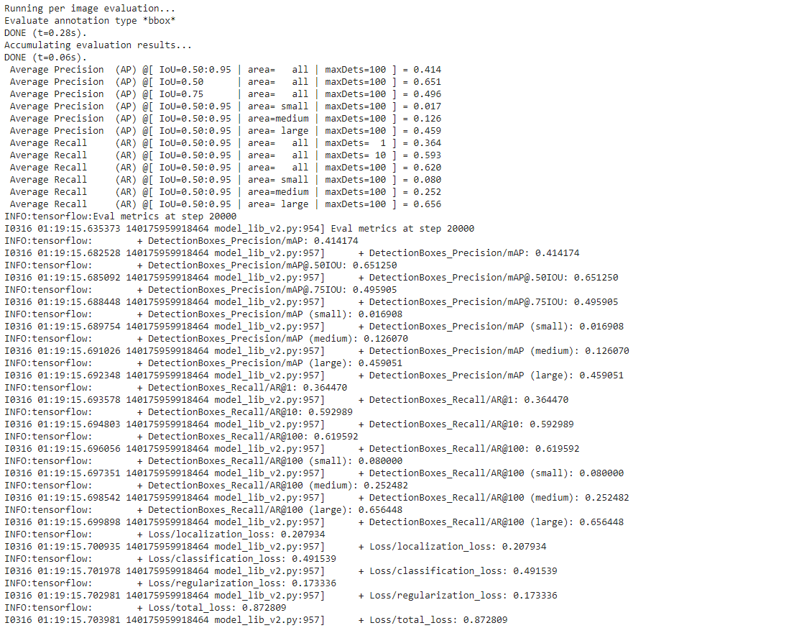

# Completed Models Training:

## Faster_rcnn_final:

Steps: 24000

Time: ~12 hours

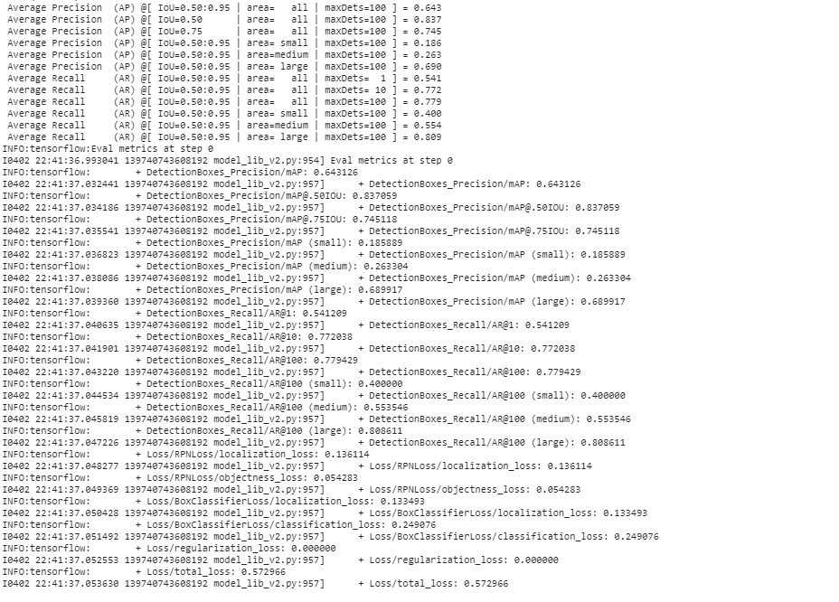

## SSD_ResNet50_Final:

Steps: 31000 on training model

Time:

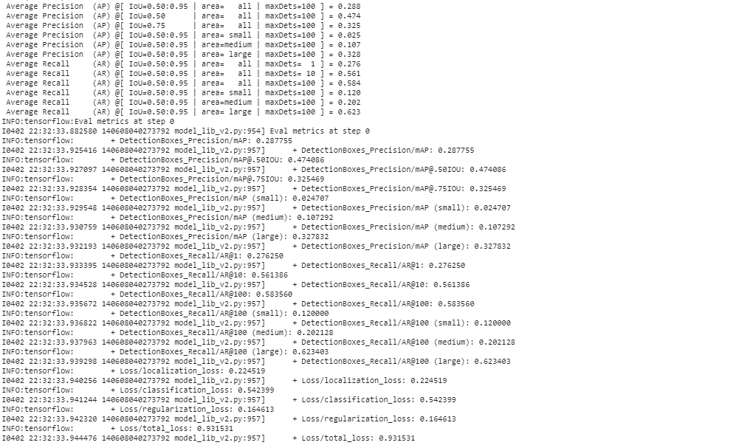

## SSD_resnet152_final

Steps: 51000

Time: ~ 20 hours

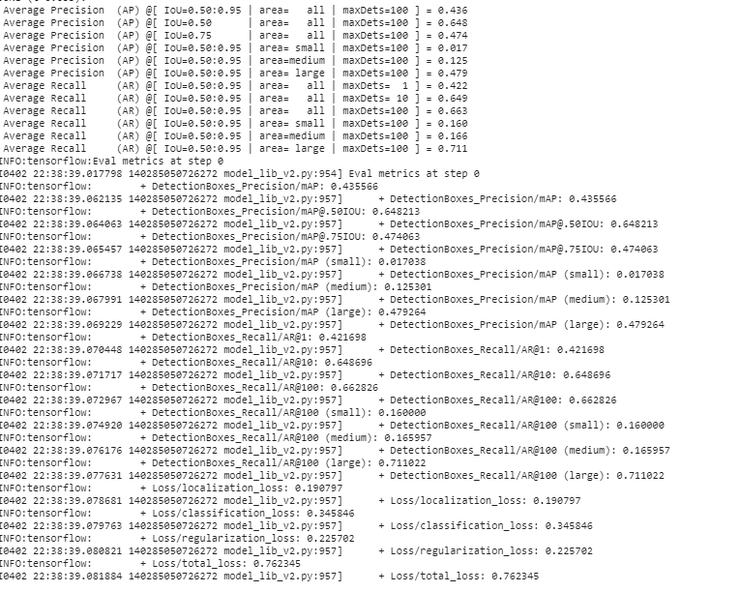

## Faster RCNN Resnet152:

Steps: 31,000

Time for training: 9.4 hours

mAP: 0.58

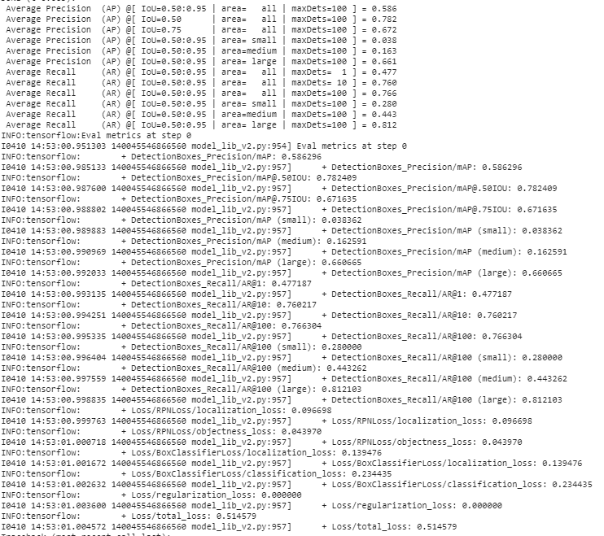

# Confusion Matrices:

## Faster RCNN Resnet 50:

|  |  |  |  |
| --- | --- | --- | --- |
| Image | TP | FP | FN |
| 1 | 2 | 1 | 0 |
| 2 | 4 | 0 | 0 |
| 3 | 2 | 2 | 0 |
| 4 | 1 | 4 | 1 |
| 5 | 3 | 0 | 0 |
| 6 | 6 | 0 | 0 |
| 7 | 2 | 0 | 0 |
| 8 | 1 | 2 | 0 |
| 9 | 2 | 1 | 0 |
| 10 | 2 | 1 | 0 |
| 11 | 3 | 1 | 0 |
| 12 | 2 | 0 | 0 |
| 13 | 2 | 0 | 1 |
| 14 | 4 | 0 | 0 |
| 15 | 3 | 1 | 0 |
| 16 | 4 | 0 | 0 |
| 17 | 4 | 0 | 0 |
| 18 | 3 | 0 | 0 |
| 19 | 2 | 0 | 1 |
| 20 | 2 | 0 | 0 |
| 21 | 2 | 0 | 0 |
| 22 | 2 | 0 | 0 |
| 23 | 4 | 0 | 1 |
| 24 | 2 | 0 | 1 |
| 25 | 6 | 1 | 3 |
|  | 70 | 14 | 8 |

True Positive: 70

False Positive: 14

False Negative: 8

|  |  |
| --- | --- |
| TP = 70 | FP = 14 |
| FN = 8 |  |

## Faster RCNN Resnet 152:

|  |  |  |  |
| --- | --- | --- | --- |
| Image | TP | FP | FN |
| 1 | 2 | 0 | 0 |
| 2 | 4 | 0 | 0 |
| 3 | 2 | 1 | 0 |
| 4 | 1 | 2 | 2 |
| 5 | 3 | 0 | 0 |
| 6 | 5 | 1 | 0 |
| 7 | 2 | 0 | 0 |
| 8 | 1 | 0 | 0 |
| 9 | 2 | 2 | 0 |
| 10 | 2 | 1 | 0 |
| 11 | 3 | 0 | 0 |
| 12 | 2 | 0 | 0 |
| 13 | 2 | 0 | 1 |
| 14 | 4 | 0 | 0 |
| 15 | 3 | 1 | 0 |
| 16 | 4 | 0 | 0 |
| 17 | 4 | 0 | 0 |
| 18 | 3 | 0 | 0 |
| 19 | 2 | 0 | 1 |
| 20 | 2 | 0 | 0 |
| 21 | 2 | 0 | 0 |
| 22 | 2 | 1 | 0 |
| 23 | 5 | 0 | 0 |
| 24 | 2 | 0 | 1 |
| 25 | 6 | 1 | 3 |
|  | 70 | 10 | 8 |

True Positive: 70

False Positive: 10

False Negative: 8

|  |  |
| --- | --- |
| TP = 70 | FP = 10 |
| FN = 8 |  |

## SSD Resnet 50:

|  |  |  |  |
| --- | --- | --- | --- |
| Image | TP | FP | FN |
| 1 | 2 | 0 | 0 |
| 2 | 2 | 0 | 2 |
| 3 | 1 | 0 | 1 |
| 4 | 0 | 1 | 3 |
| 5 | 1 | 0 | 2 |
| 6 | 4 | 1 | 2 |
| 7 | 2 | 0 | 0 |
| 8 | 1 | 0 | 0 |
| 9 | 2 | 0 | 0 |
| 10 | 2 | 0 | 0 |
| 11 | 1 | 0 | 2 |
| 12 | 2 | 0 | 0 |
| 13 | 0 | 0 | 3 |
| 14 | 1 | 0 | 3 |
| 15 | 2 | 0 | 1 |
| 16 | 3 | 0 | 1 |
| 17 | 3 | 0 | 1 |
| 18 | 1 | 0 | 2 |
| 19 | 2 | 0 | 1 |
| 20 | 1 | 0 | 1 |
| 21 | 1 | 1 | 1 |
| 22 | 2 | 0 | 0 |
| 23 | 3 | 0 | 2 |
| 24 | 2 | 0 | 1 |
| 25 | 1 | 0 | 7 |
|  | 42 | 3 | 36 |

True Positive: 42

False Positive: 3

False Negative: 36

|  |  |
| --- | --- |
| TP = 42 | FP = 3 |
| FN = 36 |  |

## SSD Resnet 152:

|  |  |  |  |
| --- | --- | --- | --- |
| Image | TP | FP | FN |
| 1 | 1 | 0 | 1 |
| 2 | 2 | 0 | 2 |
| 3 | 1 | 0 | 1 |
| 4 | 0 | 1 | 3 |
| 5 | 2 | 0 | 1 |
| 6 | 4 | 0 | 2 |
| 7 | 1 | 0 | 1 |
| 8 | 1 | 0 | 0 |
| 9 | 1 | 0 | 1 |
| 10 | 2 | 0 | 0 |
| 11 | 1 | 0 | 2 |
| 12 | 2 | 0 | 0 |
| 13 | 0 | 0 | 3 |
| 14 | 1 | 1 | 3 |
| 15 | 2 | 0 | 1 |
| 16 | 2 | 0 | 2 |
| 17 | 3 | 0 | 1 |
| 18 | 3 | 0 | 0 |
| 19 | 2 | 0 | 1 |
| 20 | 2 | 0 | 0 |
| 21 | 2 | 0 | 0 |
| 22 | 2 | 0 | 0 |
| 23 | 2 | 0 | 3 |
| 24 | 1 | 0 | 2 |
| 25 | 1 | 0 | 7 |
|  | 41 | 2 | 37 |

True Positive: 41

False Positive: 2

False Negative: 37

|  |  |
| --- | --- |
| TP = 41 | FP = 2 |
| FN = 37 |  |